**PROBLEM STATEMENT**

Create IAM user and give full access to S3.

1.Log into AWS console and search for IAM, click on it.

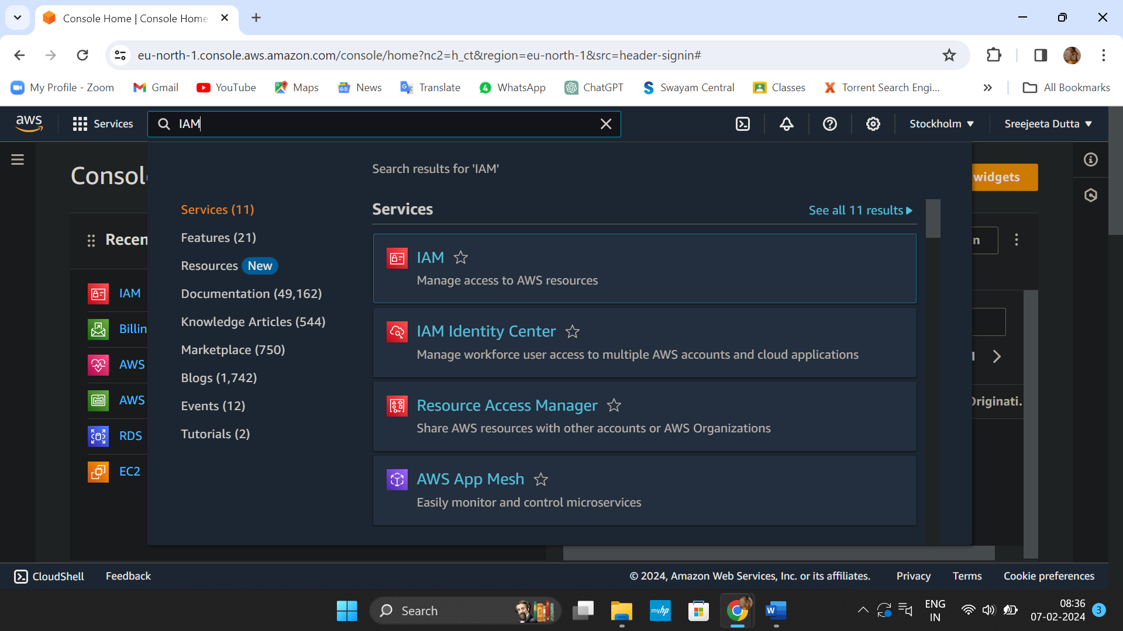

2. Under IAM resources click on ‘Users’.

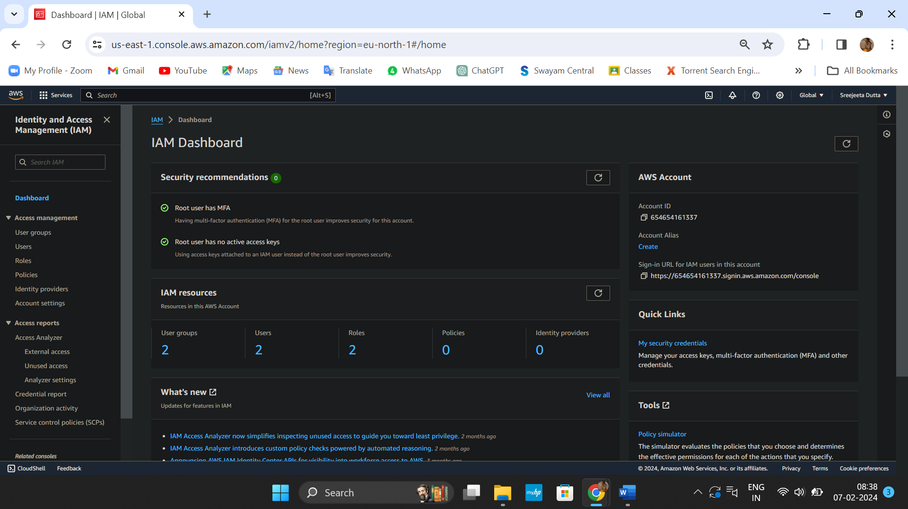

3. Click on ‘Create User’.

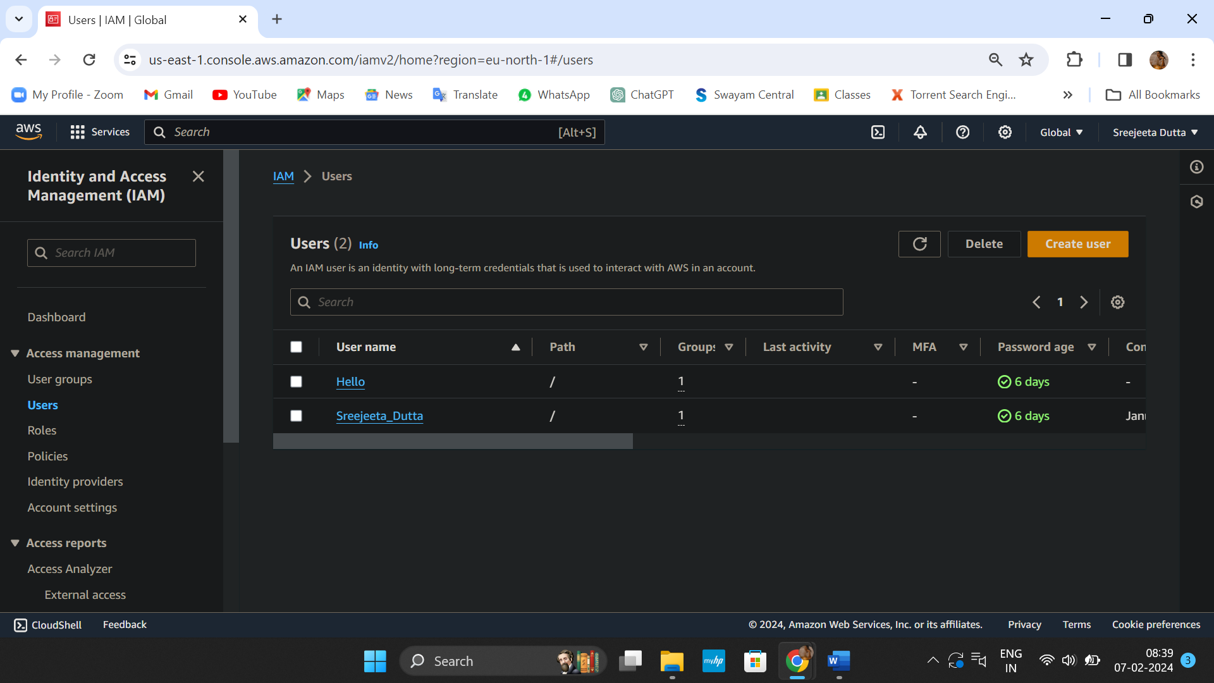

4. Provide ‘User details’, tick off the check box and follow the snapshot given below.

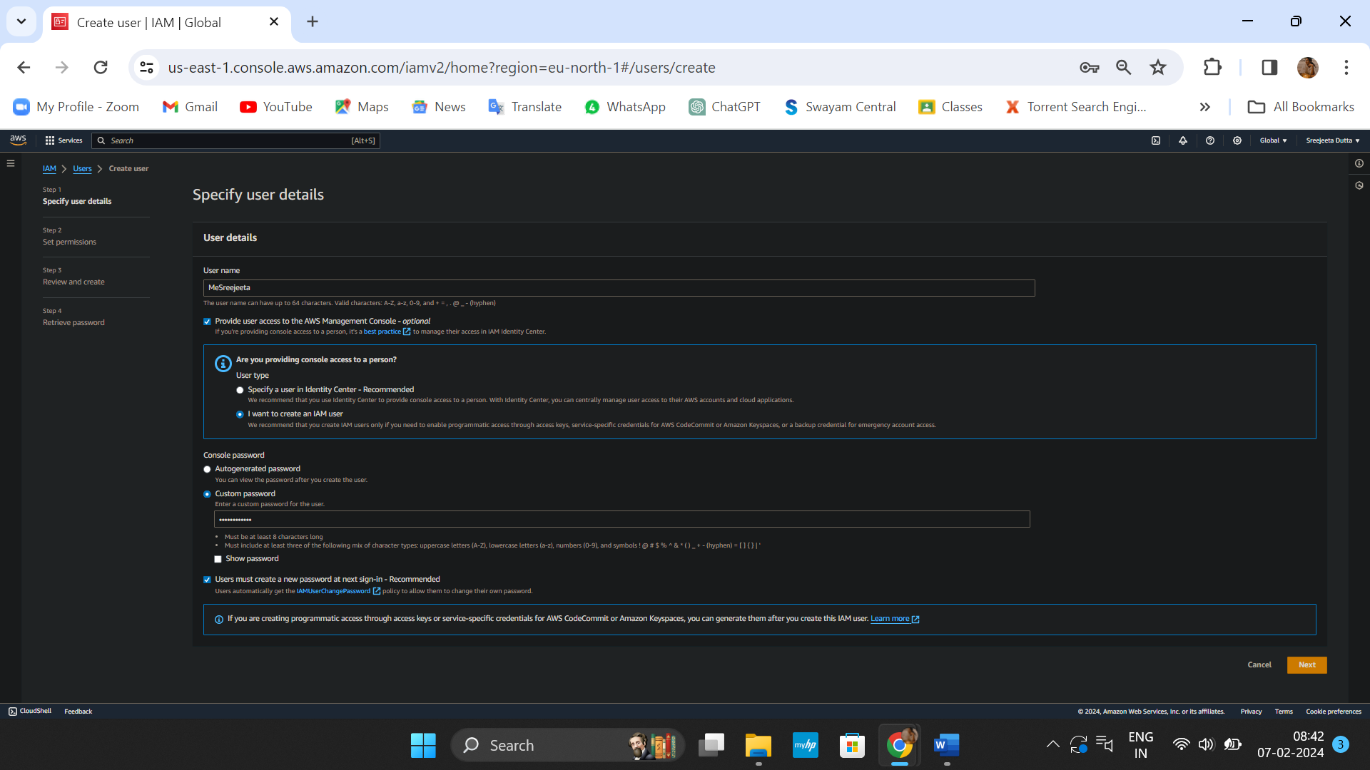

5. Under ‘Permissions options’, click on ‘Add user to group’ and go to ‘Create group’.

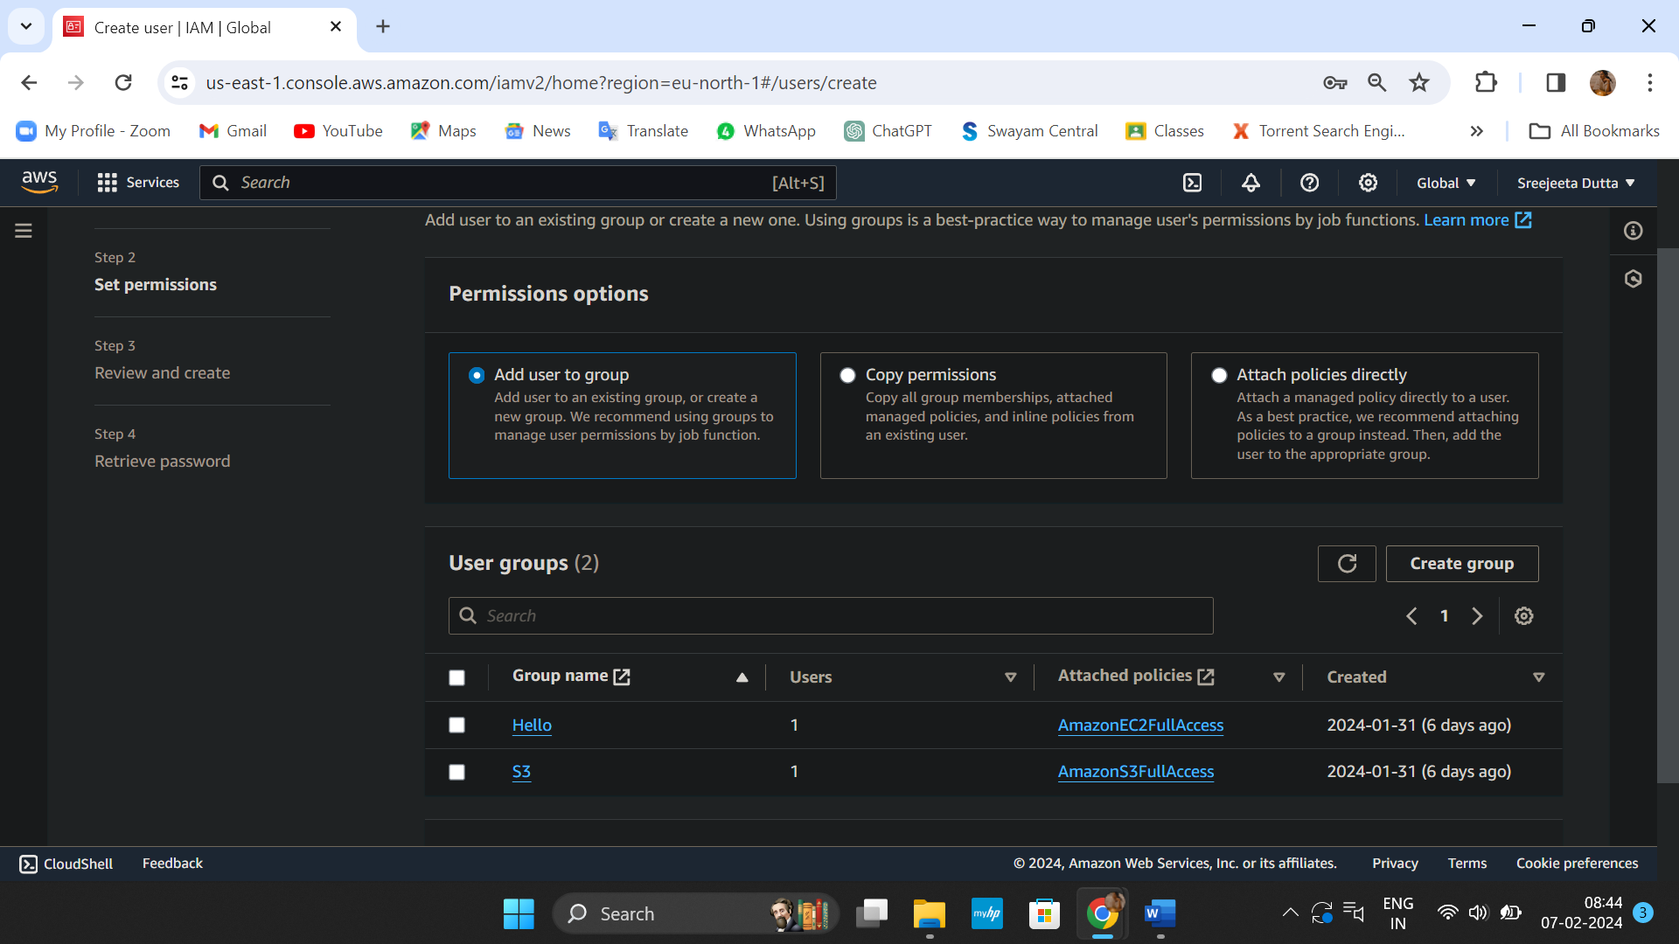

6. To ‘Create user group’, first provide ‘User group name’, then from permission policies search for s3 and choose full access of the particular permission we want to give to that group.

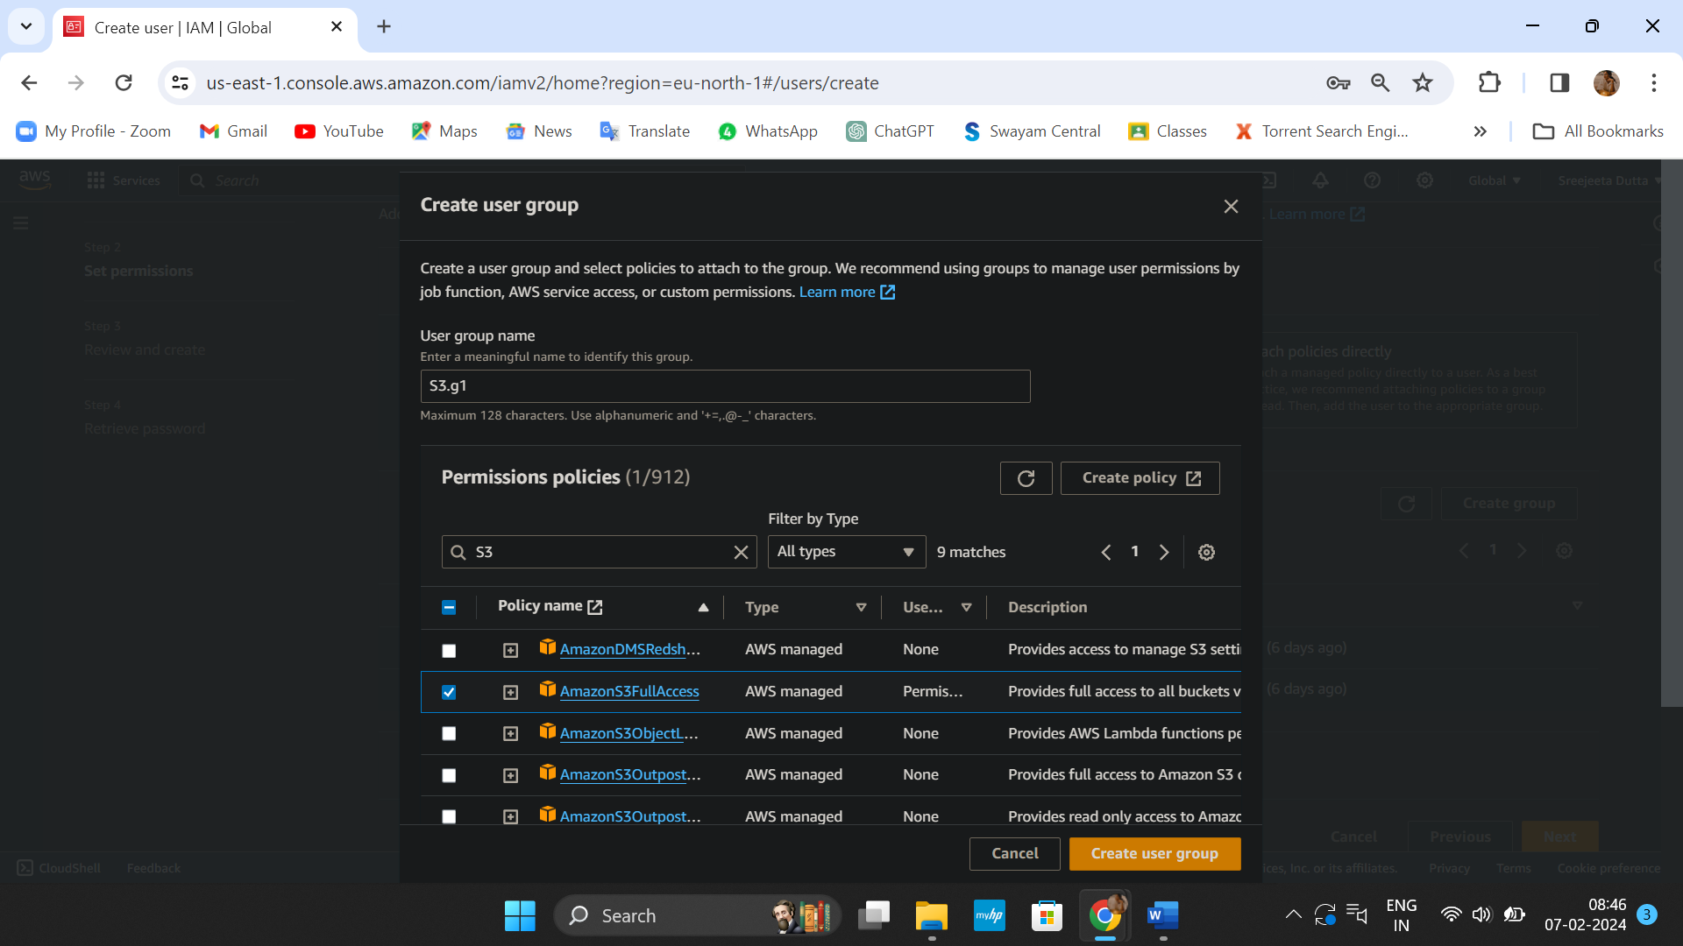

7. ‘S3.g1’ is successfully created, then tick off the checkbox of ‘S3.g1 in ‘User groups’, so that our IAM user is connected to this group and gets the required permission then click on ‘Next’.

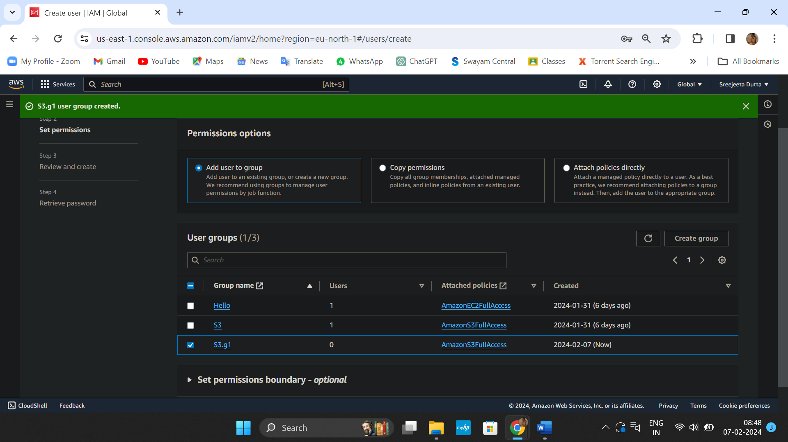

8. Under ‘Review and create’, click on ‘Create user’ to create our IAM user.

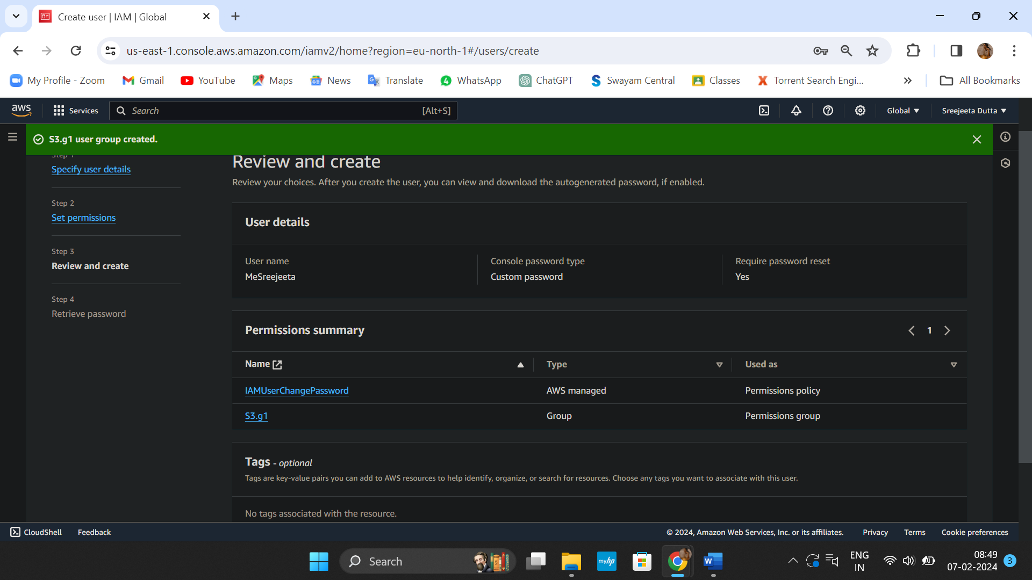

9. IAM user is created successfully and click on ‘Return to users list’. ‘MeSreejeeta’ is created successfully and it is shown in ‘Users’.

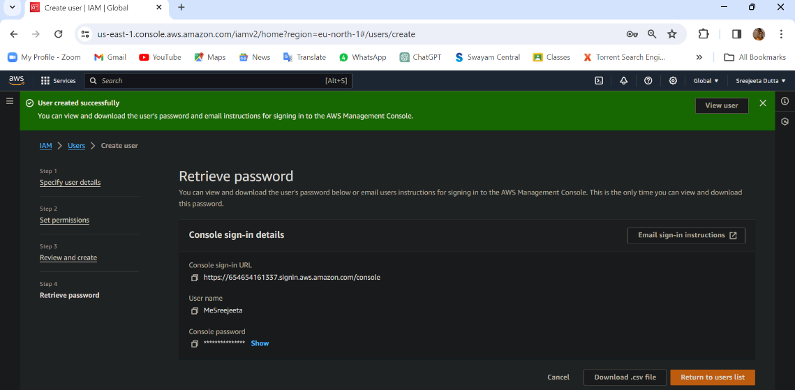

10.Now sign out from root user and open new ‘Incognito mode’, login to AWS console as IAM user with provided account ID, IAM username and password. 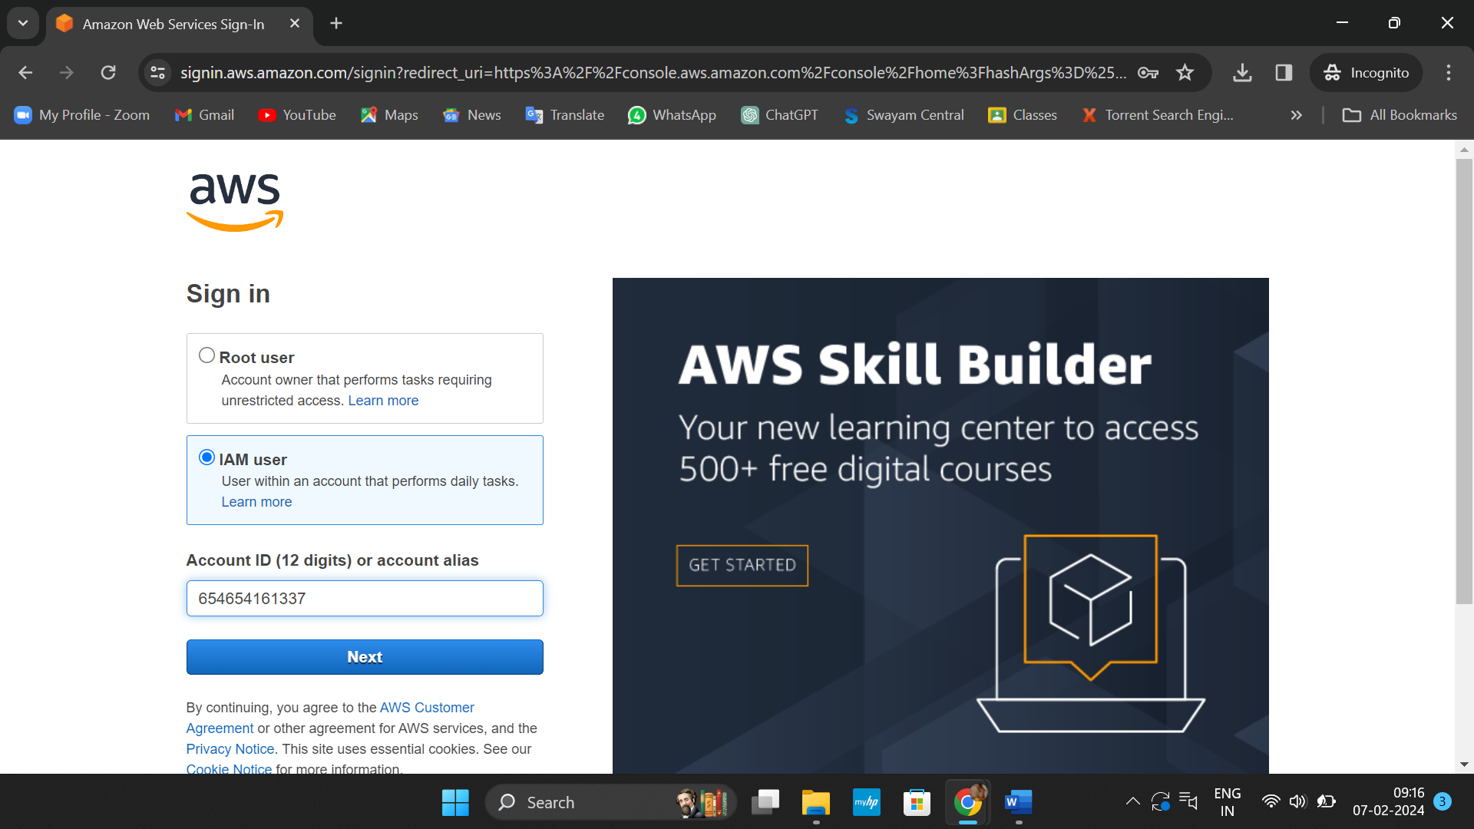

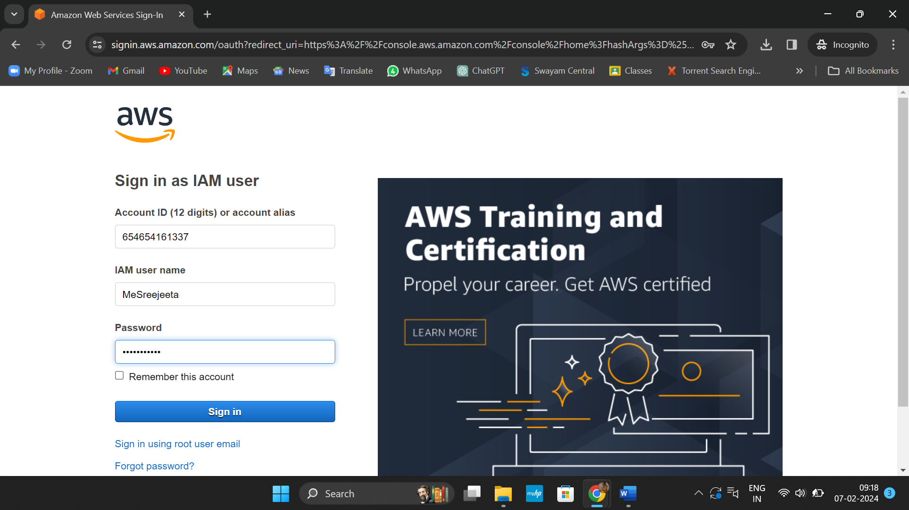

11.Successfully logged into ‘MeSreejeeta’ user account.

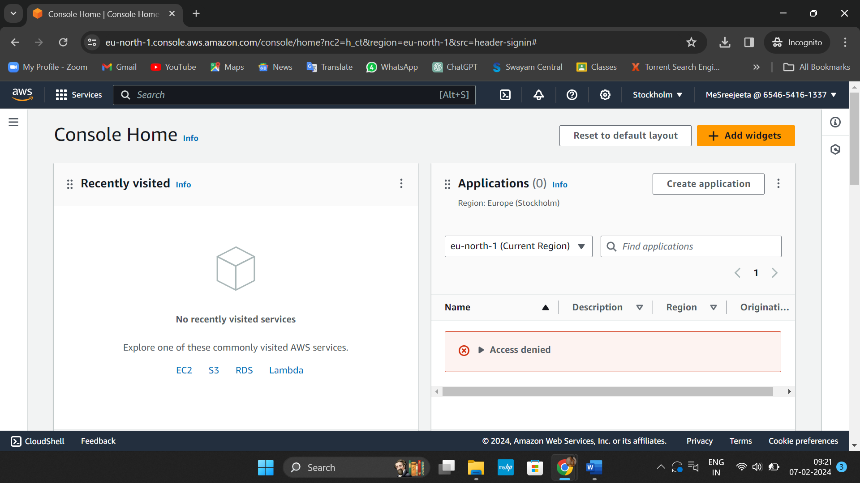

12.We search for ‘S3’ and then click on it.

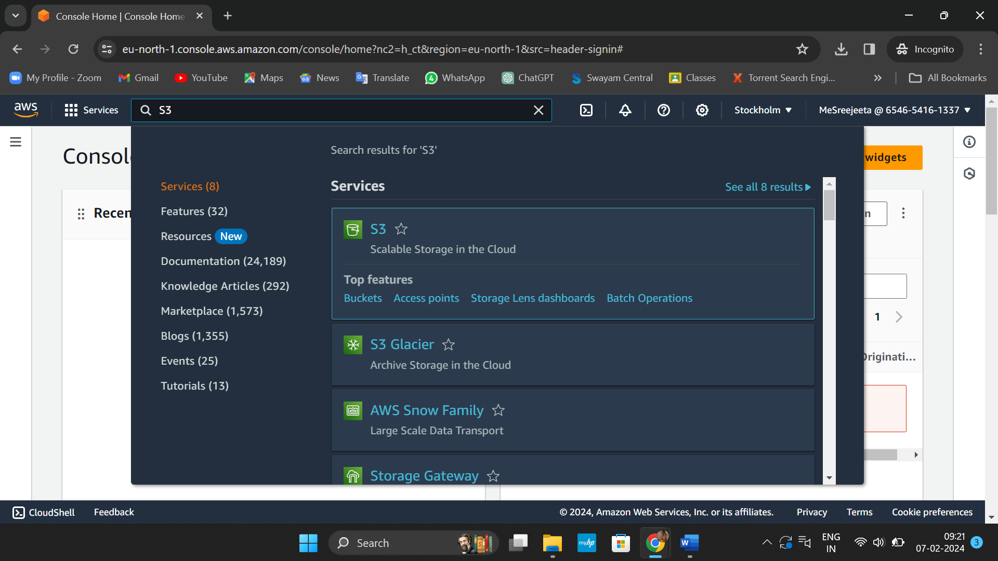

13.It is seen that IAM user is given full access to ‘S3’ successfully.

